**Zautomate setup in eclipse in WIN machine**

**Requirements:**

* Java 8 0r 7 (please set environment variable)
* Eclipse (Luna, Mars or any)
* Maven, TestNG plugins ( install Eclipse Marketplace)
* GitHub Desktop for windows
* Maven jar in local ( to create executable jar )

**Configuration:**

1. To download ‘qa-automation’ package from GitHub, install GitHub desktop on your windows machine

<https://github.com/ZillionGroup/qa-automation>

1. Select directory as C:/ workspace

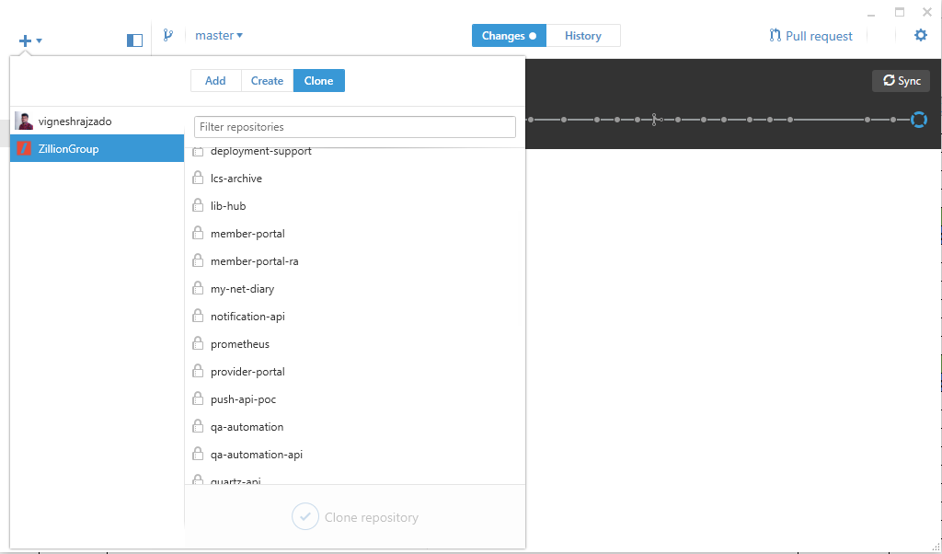

1. Select ‘qa-automation’ and Clone the repository. Entire project will be cloned under local windows machine.
2. Eg. In WIN machine we used the following steps in eclipse,
3. File -> Import…
4. Now File -> Import… -> Existing Maven Project -> Browser and locate ‘zillionqa’
5. 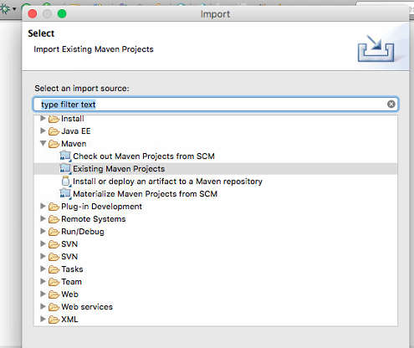
6. Current path in WIN machine: C:\workspace\qa-automation\zillionqa
7. Setup all your property files and test cases in your desired location (Eg: C:/workspace/qa-automation/Zillion/testcases)
8. If you want to execute from eclipse -> Just run as ProgramTestNG class as java application.
9. Please check VM arguments in Run Configuration:
10. If you want to run without grid, leave as empty in –Dzado.grid= else give value as grid.

*-Dzado.reporter.config=C:\workspace\qa-automation\Zillion\testcases\zillion.properties -DlogfileLoc=C:\Logs -Dzado.execution.parseq=sequential -Dzado.grid=*

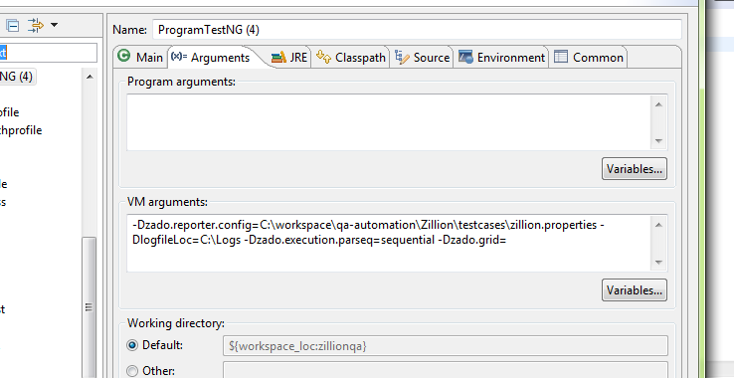

1. Then Run
2. It will execute the suite based on your configuration.
3. If you want to execute without eclipse. You have to install maven jar (need to set environment variable) in your machine and create an executable jar to framework.
4. Open terminal -> Then navigate upto “C:/workspace/qa-automation/zillionqa”
5. Then use “mvn install package” -> Enter

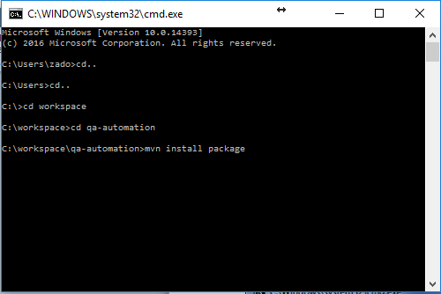

1. It will create that executable jar in “C:/workspace/qa-automation/zillionqa/target” location as “zillionqa-jar-with-dependencies.jar”.
2. Create/copy a bat file for command line execution. Just edit and change the property file path inside the command file. Find the attachment “zadobat.bat”
3. Then double click zadobat.bat and it will execute the suite as well.
4. To update the latest committed scripts from others and test cases:

Open GitHub desktop and click ‘sync’

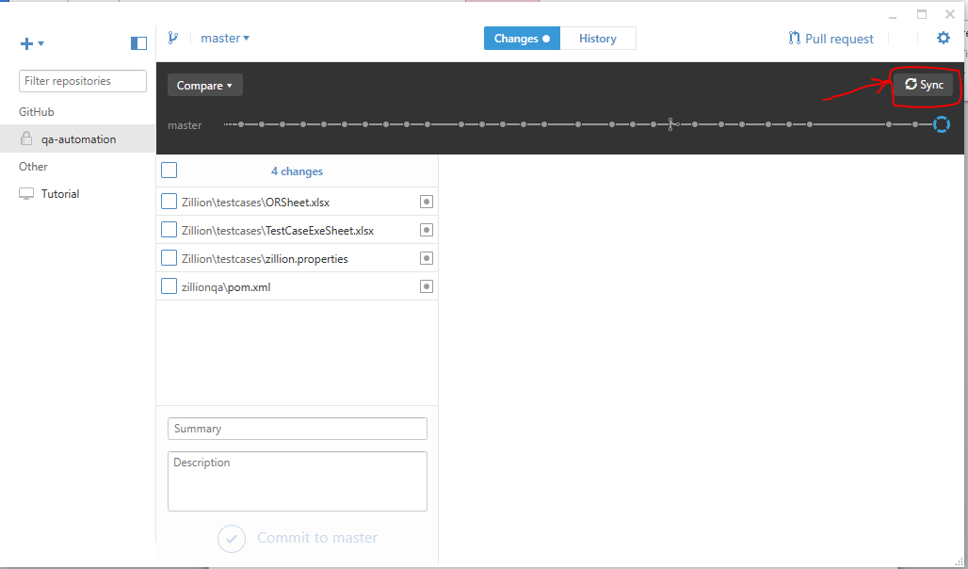

1. To commit the latest modified scripts select the checkboxes that needs to be committed. Type the summary for the modification and click ‘Commit to master’. Finally ‘Sync’ once you commit the scripts.

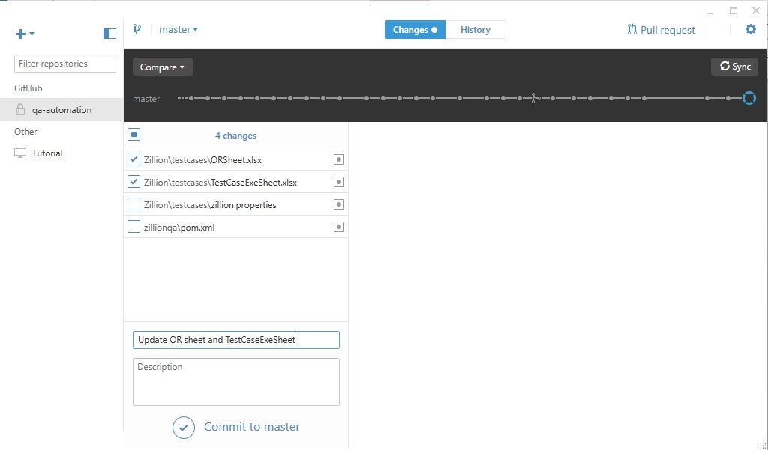

**Note:**

Before execution need to configure TestcaseExeSheet.

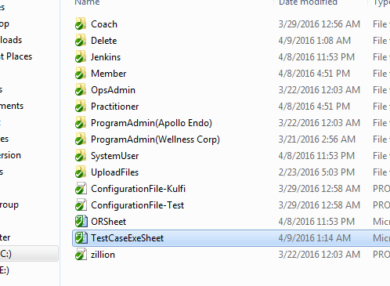

GRID:

STEP 1:

NEED TO LAUNCH HUB

Kindly launch the following bat file to run hub. ()

*qa-automation\zillionqa\target\src\main\resources\grid\pathforhub.bat*

STEP 2

NEED TO LAUNCH NODE

qa-automation\zillionqa\target\src\main\resources\grid

*Copy this particular folder and paste in the node system (any location).

*\*Then run pathfornode.bat file in node system.*

Note: Make sure you have changed your node IP based on your node system.

Eg:

*CMD /k java -jar selenium-server-standalone-3.0.1.jar -role node -hub* [*http://192.168.1.23:4444/grid/register -port 5555*](http://192.168.1.23:4444/grid/register%20-port%205555)

To check your Grid console: Type following url :-

*http://localhost:4444/grid/console*

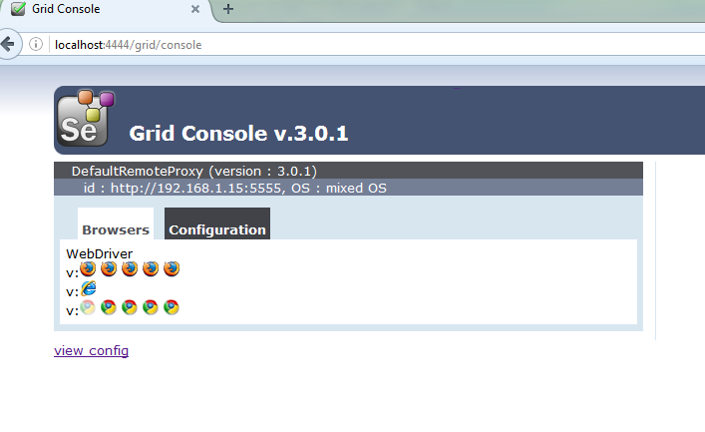

STEP 3

AFTER CONNECTED HUB AND NODE SUCCESSFULLY

Give your node ip address in zillion property file (in zado.Grid.name=)

STEP 4

CHANGE YOUR VM ARGUMENTS IN ECLIPSE:

Eg: -Dzado.reporter.config=C:\workspace\qa-automation\Zillion\testcases\zillion.properties -DlogfileLoc=C:\Logs -Dzado.execution.parseq=sequential -Dzado.grid=grid

STEP 5

RUN YOUR SCRIPT